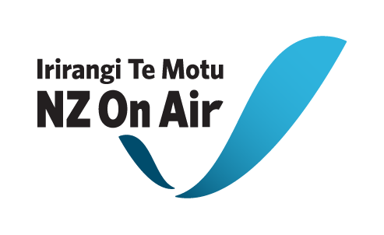

Production Funding Contract Initiation Form

Please note: NZ On Air will begin drafting your funding contract once we receive both this
form, platform confirmations of your rights and completed necessary attachments from you. We aim to have a draft contract back to you within 2 working weeks of receiving your initiation, providing all this information from you is complete and correct.

Full Legal Name of your Company:

Location of Company’s Registered Office (City Only):

Main Content Details (content to be distributed via Primary Platform)
Content Title
Number of Episodes
Duration of Episodes | e.g. 44’00” being 1 commercial hour
Total Duration
Transmission Date/s | First Episode: Last Episode: / TBC

Other Content Details (any content to be distributed via Additional Platform/s or Social Media)
Type of content | e.g. stand alone website, articles, audio features
Platform/s for other content | e.g. name of channel, website, social media site, radio station
Number of Episodes | If Applicable
Duration of Episodes | If Applicable e.g. 44’00” being 1 commercial hour
Total Duration
Release Date/s | First Episode: Last Episode: / TBC
Other details | e.g. minimum number of non-AV articles etc to be produced as part of the budget

Key Personnel
(Our consent will be required to change these personnel. Please include all Key Roles, starting but not limited to roles listed below)
Producer(s)
Director(s)
Writer(s)
Presenter
Other

Rights Details
Primary Platform Owner
Channel/website
Broadcast Timeslot | If applicable e.g. Peak/Off-peak and time and TX date if known
Primary Platform Rights | ____ plays over ____ years for free-to-air  ____ plays over ____ years for Pay TV  Online: Mobile: Other: (please specify)
Additional Platform Owner | If applicable
Channel/website | If applicable
Broadcast Timeslot | If applicable e.g. Peak/Off-peak and time and TX date if known
Additional Platform Exclusive Rights | If applicable
Producer Contact Details
Physical Address | (Please ensure you put correct postal code for both addresses)
Postal Address
Email
Phone (landline & mobile)
Attention
Production Bank Account number:

Budget & Funding Details
Budgeted Costs | Budgeted Cash Costs
 | Budgeted Non-Cash Costs
 | Total Budgeted Costs
Funding | NZ On Air Development Funding (if applicable)
 | NZ On Air Production Funding
 | Total NZ On Air Funding
 | Primary Platform Funding
 | Additional Platform Funding
 | Total Platforms Funding
 | Producer’s Funding
Third Party Funding
(Specify funders)
 | Total Funding

Insurance:
Do you have, or are you planning to get, any insurance specifically for this the production of this funded content?

□ No (Please note that the funding agreement will require you to have Insurance cover as is prudent. It is not necessary to have project specific insurance but we do expect you to at least have various blanket insurance agreements which will cover some risks)

□ Yes (Please write list of insurance types you have or are planning to get below)
Necessary Attachments:
□ Drawdown Schedule.
NZ On Air has default drawdowns for different types of productions. These are set out in our Drawdown section on our website. We prefer to round the drawdown amounts.
If this default position is not suitable for your production please provide a preferred drawdown schedule. Note that your drawdowns should be tied to production events (e.g. offline approval) rather than dates. 5% should be reserved for payment on delivery to the Platform and the larger of either 5% or the Production Company Overhead, for delivery of final reports and a USB/DVD copy to us. Please note that no funds will be released until satisfactory documentation has been completed.

□ Production Schedule (Please specify preproduction, shoot, offline & delivery dates).
□ Highlighted Project Budget.
Important: Please specify/ highlight items in your budget that will/ may be internal or Related Party Cost items.
By Related Party Costs we mean any payment to the Applicant; any shareholder, director, or employee of the Applicant; any near relative of a shareholder or director of the Applicant; and any entity in which any director, shareholder or near relative has a financial interest, or any payment for the producers internal costs, such an edit suite, camera’s etc. The Producer is not to increase the rate for Related Party Costs highlighted in the Project Budget without the written consent of NZ On Air. The Project Budget is to be approved by NZ On Air before issuing the contract for signing.

□ If applicable, a full schedule of Non Cash items to be used for this production. Including, but not limited to, any Platform facilities provided as part of the platform funding.

□ Net Income Shares: Our standard terms for net income shares are 75% in favor of the Producer, unless the project involves significant Producer or third party equity investment.

