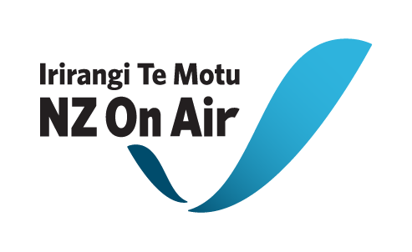

Development Funding

Contract Initiation Form for Development Funding

Please note: NZ On Air will begin drafting your development funding contract once we receive both this form and completed necessary attachments from you. We aim to have a draft contract back to you within 2 working weeks of receiving your initiation, providing all this information from you is complete and correct.

Full Legal Name of your Company (Please contact NZ On Air if no Company yet formed):

Location of Company’s Registered Office (City Only):

Content Details
Content Title
Funding Stream | e.g. Scripted or Factual
Programme Genre | e.g. Drama, Comedy, Documentary, Children’s
Number & Duration of Episodes
Delivery Date of development | Date that the materials will be delivered to NZ On Air
Platform (company) | If applicable
Platform Channel | If applicable

Key Personnel
(Our consent will be required to change these personnel)
Platform Commissioning Editor | If applicable
Executive Producer
Producer(s)
Director(s)
Writer(s)/ Other | e.g. CEO, Presenter, etc

Qualifications or restrictions on producers Rights
Scriptwriter’s right of Reversion (if any)
Date
Option Expiry Date
Any other Restrictions | (e.g. any chain of title rights required for this development to move into production, particularly if they have an expiry date)
Contact Details
Physical Address | (Please ensure you put correct postal code for both addresses)
Postal Address

Email
Phone (landline & mobile)
Fax
Attention
Production Bank Account number:

Budget & Funding Details
Budgeted Costs | Budgeted Cash Costs
 | Budgeted Non-Cash Costs
 | Total Budgeted Costs
Previous Funding (if any) | Total Previous NZ On Air Development Funding
 | Total Previous Platform Development Funding
 | Previous Producers Funding
Third Party Previous Funding
(Specify funders)
 | Total Previous Funding

Funding | Total NZ On Air Development Funding
 | Total Platform Development Funding
 | Producers Funding
Third Party Funding
(Specify funders)
 | Total Development Funding

Please note: we will be unable to pay any invoices of this current contract until funding due for this project under any previous NZ On Air development contract has been paid in full.
Please list Deliverables (e.g. 2 x First Draft Scripts, 8 x 1 page storylines etc.):

Insurance:
Do you have, or are you planning to get, any insurance specifically for this funded development stage?

□ No (Please note that the funding agreement will require you to have Insurance cover as is prudent. It is not necessary to have project specific insurance but we do expect you to at least have various blanket insurance agreements which will cover some risks)

□ Yes (Please write list of insurance types you have or are planning to get below)

Necessary Attachments:
□ Drawdown Schedule.
The drawdown schedule for development funding is usually 50% on contract execution & delivery of writer’s agreements and 50% on delivery of Deliverables and final cost report to us. Variations may be considered but there will need to be a compelling rationale to change the usual drawdown structure.
Please note that no funds will be released until satisfactory documentation has been completed.

□ Development Schedule (up to the delivery of the deliverables)
□ Development Budget
Important: Please highlight items in your budget that will/ may be internal or Related Party Cost items.
By Related Party Costs we mean any payment to: the Applicant; any shareholder, director, or employee of the Applicant; any near relative of a shareholder or director of the Applicant; and any entity in which any director, shareholder or near relative has a financial interest, or any payment for the producer’s internal costs, such an edit suite, cameras etc. The Producer is not to increase the rate for Related Party Costs highlighted in the Production Budget without the written consent of NZ On Air.
Also note: We do not allow a Production Company Overhead to form part of the contracted development budget.

