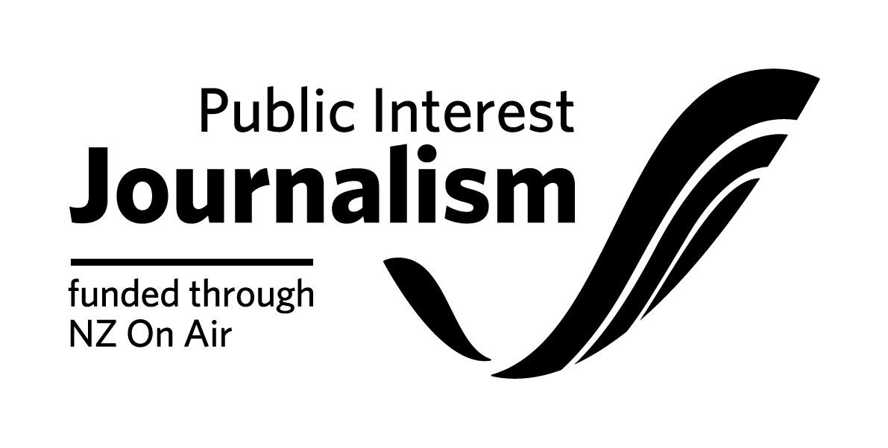

Industry Development Funding Contract Initiation Form

Please note: NZ On Air will begin drafting your funding contract once we receive both this
form and completed necessary attachments from you. We aim to have a draft contract back to you within 3 working weeks of receiving your initiation, provided all the information from you is complete and correct.

Full Legal Name of your Company:

Location of Company’s Registered Office (City Only):

Necessary attachments to go with the below form:
□ Project Budget
Important: Please specify/highlight items in your budget that will/may be internal or Related Party Cost items.
By Related Party Costs we mean any payment to the Applicant; any shareholder, director, or employee of the Applicant; any near relative of a shareholder or director of the Applicant; and any entity in which any director, shareholder or near relative has a financial interest, or any payment for the producers internal costs, such an edit suite, camera’s etc. The Producer is not to increase the rate for Related Party Costs highlighted in the Project Budget without the written consent of NZ On Air. The Project Budget is to be approved by NZ On Air before issuing the contract for signing.
□ Drawdown Schedule.
NZ On Air has default drawdowns for different types of projects. These are set out in our Drawdown section on our website. We prefer to round the drawdown amounts.
If this default position is not suitable for your project, please provide a preferred drawdown schedule. Note that your drawdowns should be tied to production events (e.g. offline approval) rather than dates. 5% should be reserved for payment on delivery of the IDF project and 5% for delivery of final reports to us. Please note that no funds will be released until satisfactory documentation has been completed.
□ Project Schedule (Please specify applicable research, preproduction, shoot, offline, delivery, release dates).
□ If applicable, a full schedule of Non Cash items to be used for this production. Including, but not limited to, any Platform facilities provided as part of the platform funding.
□ Net Income Shares: Our standard terms for net income shares are 75% in favor of the Production Company, unless the project involves significant Producer or third party equity investment.
□ A commitment that in recognition of this public media funding you will employ the use of common data metrics where possible and the provision of our audience engagement, output and financial data as required. You agree you will work with NZ On Air to agree upon and meet these data metrics.

Main Project Details
Project Title
Nature of Project | E.g. training programme, internship
Description of Project | e.g. detailed description of the project
Project dates | Start date: Completion date:  (Please add in further dates to outline clear milestones of the Project)

Key Personnel
(Our consent will be required to change these personnel. Where possible at this point, please include all Key Roles, starting but not limited to roles listed below)
Mentor(s)
Programme Co-Ordinator/ Manager
Total Number of trainees/interns/cadets | [as based on the funding proposal submitted]
Other | [any other key participants related to this project]

Recipient Contact Details
Main contact person
Email address
Physical Address | (Please ensure you put correct postal code for both addresses)
Postal Address
Phone (landline & mobile)
Project Bank Account number

Budget & Funding Details
Budgeted Costs | Budgeted Cash Costs
 | Budgeted Non-Cash Costs
 | Total Budgeted Costs
Funding | NZ On Air Funding
 | Producer/Primary Platform Funding
 | Additional Funding
 | Total Funding

Insurance:
Do you have, or are you planning to get, any insurance specifically for the production of this funded content?

□ No (Please note that the funding agreement will require you to have Insurance cover as is prudent. It is not necessary to have project-specific insurance but we do expect you to at least have various blanket insurance agreements which will cover some risks)

□ Yes (Please write list of insurance types you have or are planning to get below)

