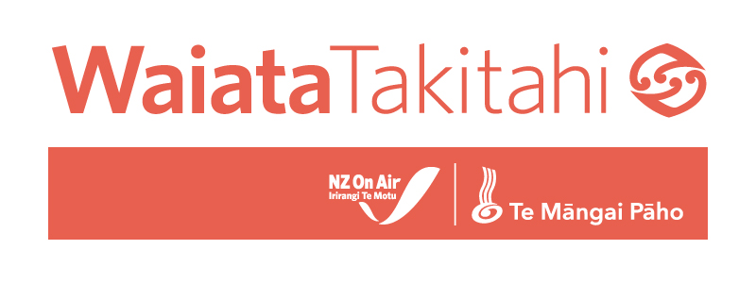

WAIATA TAKITAHI FUNDING: Application Guidelines

E karanga ana ki ngā kaiwaiata, ngā kaipuoro me ngā kaipuoro ataata kia arotahi mai ki tēnei kaupapa o Waiata Takitahi!

Introduction - What is Waiata Takitahi?

Waiata Takitahi – (‘single song’) – is a new co-fund launched as a collaboration between NZ On Air and Te Mangai Pāho. This is the first time the two funding agencies have officially joined forces on a music funding initiative.
The ambition for this new fund is to enable brand new songs with strong te reo Māori lyrical content that have a good chance to cross to mainstream audiences.
We are seeking applications from New Zealand artists who are interested in recording and releasing a bilingual single with potential general audience appeal and a minimum of 25% te reo Māori in the song lyrics. We are looking for songs that will target online and broadcast audiences and have potential to find a home on mainstream playlists.

Artists can come from any background but the use of te reo Māori in the song will have to be supported by a language consultant to ensure correct usage, context and pronunciation. Having a language consultant confirmed by the application deadline is preferred as it is advantageous to your project, however all applicants will receive the same opportunity and assistance to recruit a suitable language consultant post-deadline, if their application is successful.

Funding of up to $14,000 (plus GST if registered) is available to put towards the costs of recording a single song, creating video content and other visual collateral, and putting resource towards promotion, publicity and marketing for the single release. Funds can also be used to pay for a te Reo Māori language consultant to ensure correct use of language and context in the final song.

Submitting an application.
Waiata Takitahi applications will ONLY be accepted online via the NZ On Air New Music Single website –
https://newmusicsingles.nzonair.govt.nz – please look for the specific Waiata Takitahi badge to click and begin your application once the round opens on 22 October.
If this is your first time submitting an application within the NZ On Air NewMusicSingle portal, you will just need to sign up first with an email and password.
To apply for funding for Waiata Takitahi you will need a recorded demo version of the song you are applying for funding for, and you will need to fill out the online application.
The application process includes working your way through a list of 25 criteria options focused on your music journey and audience engagement to date. Waiata Takitahi applicants will need to have achieved at least 5 of the 25 criteria options to proceed to the song application stage. The full list of criteria can be found here.

Funding amount – up to $14,000 (+ GST)

Waiata Takitahi grants will be available up to $14,000 (+ GST if registered).
The funding can be used towards a professional release-ready recording of the song, video content and other visual collateral to assist with the song release along with promotion, publicity and marketing. We also will expect that some of the funding will need to be utilised to engage a te reo Māori consultant to ensure correct usage of te reo in the song (minimum of 25% te reo Māori).
NZ On Air and Te Mangai Pāho are both contributing pūtea to this fund, and we expect to be able to support up to 12 song releases in this inaugural Waiata Takitahi funding round.
The grants will also incorporate the new Artist Creation Fee of $1,000 (+ GST) which is optional, and recognises the artists creation of the original song.

Timeline

Thursday 17 September | Waiata Takitahi funding announced
Thursday 22 October | Waiata Takitahi application round opens
Thursday 12 November | Application round closes at 4pm
Thursday 10 December | Funding results available, recipients notified

- Assessment criteria
Applications for Waiata Takitahi funding will be assessed internally by NZ On Air and Te Mangai Pāho based on the following criteria:
- Potential to assist with increasing levels of New Zealand music on radio
- Potential to impact online audiences with significant streams/views/shares/likes/sales
- Integration of te reo Māori in the waiata
- Track record of the artist
- Cultural value of the project for New Zealand audiences
- Strength of the overall application, plan and media targets
What you can expect
It is expected that demand for funds will outstrip our funding budgets, so not all applications will be successful in receiving funding.

The Fine print
If your application is successful, among a number of other requirements we will stipulate that:
- Producers must be aware of their obligations under the Health and Safety at Work Act 2015.
Producers of video projects are required to:
➢ follow the Health and Safety in the New Zealand Screen Sector guidelines found at http://screensafe.co.nz
➢  abide by agreed industry work standards as expressed in the Individual Performance Agreement (SPADA and NZ Actors Equity) and The Blue Book (NZ Film and Video Technicians Guild)
- The content is clearly branded as NZ On Air-funded. See our accreditation requirements here.
The following standard terms and conditions apply to your application. In submitting your proposal you are deemed to have read, understood and agree to be bound by these terms and conditions:
- you must bear all of your own costs in preparing and submitting your proposal
- you represent and warrant that all information provided to us is complete and accurate
- we may rely upon all statements made in your proposal
- we may amend, suspend, cancel and/or re-issue these guidelines at any time
- we may waive any irregularities or informalities in the application process
- we may seek clarification of any proposal and meet with any applicant
- we will not seek clarification of all proposals or meet with all applicants
- we are not bound to accept any proposal
- you will not submit in your application any data that breaches any third party right (including intellectual property rights and privacy rights) or is objectionable, incorrect or misleading
- we both agree to take reasonable steps to protect the other’s confidential information
- our obligation to protect your confidential information is subject to the Official Information Act 1982 and other legal, parliamentary and constitutional conventions
- there is no binding legal relationship between us: a successful proposal is only formally accepted if we both sign a funding contract

