New Music Pasifika  SINGLE Application Form  -Deadline: 4pm Thursday 31 January 2019.  -Submit via Email to newmusic@nzonair.govt.nz  -Applications are for funding towards the recording, music video and promotion costs of one focus single, with funding of up to $8,000 per song available for successful applicants. This is intended to be 80% of the eligible costs with applicants are expected to co-invest the other 20%  -You must submit your song with this application – either mp3 (no more than 10MB) or online link (eg. Soundcloud) | 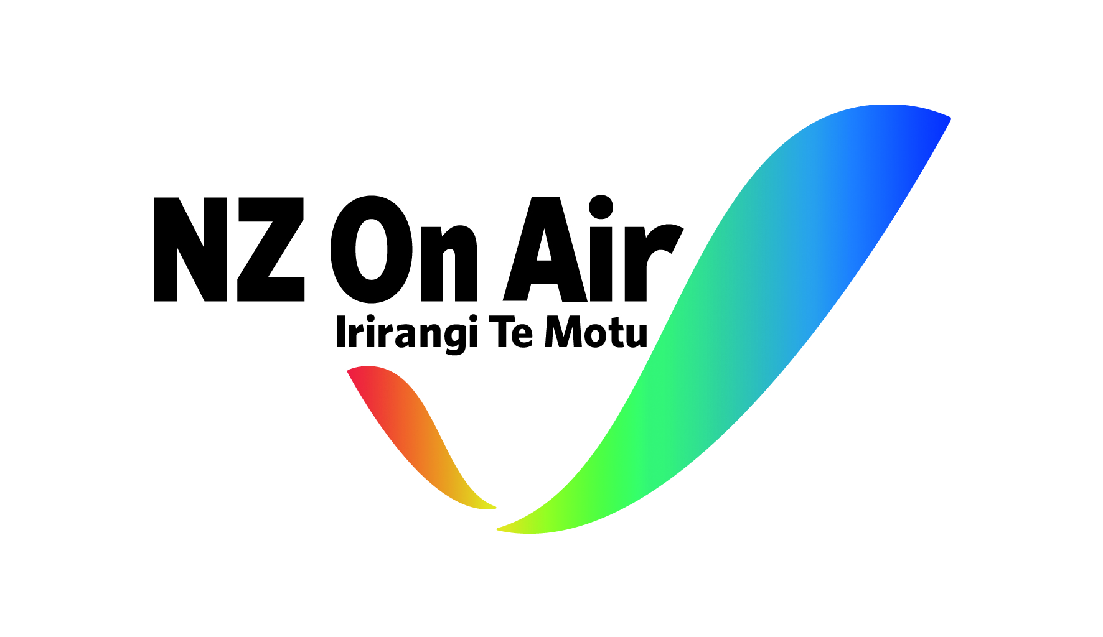

NAME OF ARTIST/GROUP:

NAME OF SONG:

SONGWRITER(S):

RIGHTS HOLDER CONTACT DETAILS:
Rights Holder is the person/s who own the rights to the song – if that’s a record label then put the record label’s contact details in this box. If owned by the artist then artist contact details go here.

Company name (if applicable):

Name:

Address:

E-mail:

Phone:

MUSIC RELEASES SO FAR:
Put a list of your most-listened to and most-viewed released music here – include links where you can. Platforms may include Spotify, Apple Music, Soundcloud, YouTube or radio stations etc. If you haven’t released anything publicly yet put N/A.

SOCIAL MEDIA:
Put the links to your different social media accounts here. This helps to indicate your fan base so far. If you don’t have any social media accounts for your group/artist, then put N/A.

Facebook Link:

Twitter Link:

Instagram Link:

Other Link:

LIVE EXPERIENCE SO FAR
Put a short list of your most significant live performances from the last two years here. Include venue and number of people at the show. If you haven’t played live before then put N/A.

YOUR PLANS FOR THE SONG
In this section we want you to write a very short overview of what you would do with the song if you were to be granted funding.
This includes any re-recording plans, music video plans, social media content, promotion and publicity etc. Also, which platforms you would be targeting with the finished song (e.g. radio, online, TV platform details)

ARTIST BIOGRAPHY:
Please attach a brief artist biography to your email application (strictly no more than one page). Please ensure the file size is under 5MB so it can be sent via email along with your song.

Additional Guidelines:
-Songs must be an original composition, cover versions will not be considered.
-The applicant must have the right to apply on behalf of the group/artist.
-Song must be sent as an mp3 file of no more than 10MB, or as an online link (e.g. Soundcloud) with download function available.
-The applying artist/group must identify as a Pasifika music artist and be New Zealand citizen/s or Permanent Resident/s.
-Applicants will be notified of results by 20 February 2019.
-Any questions can be emailed to newmusic@nzonair.govt.nz

